Create a Module pool program with the following attributes.

Screen number 001(Normal screen) with area named SUBSA and two pushbuttons.

screen numbered 2 is a subscreen.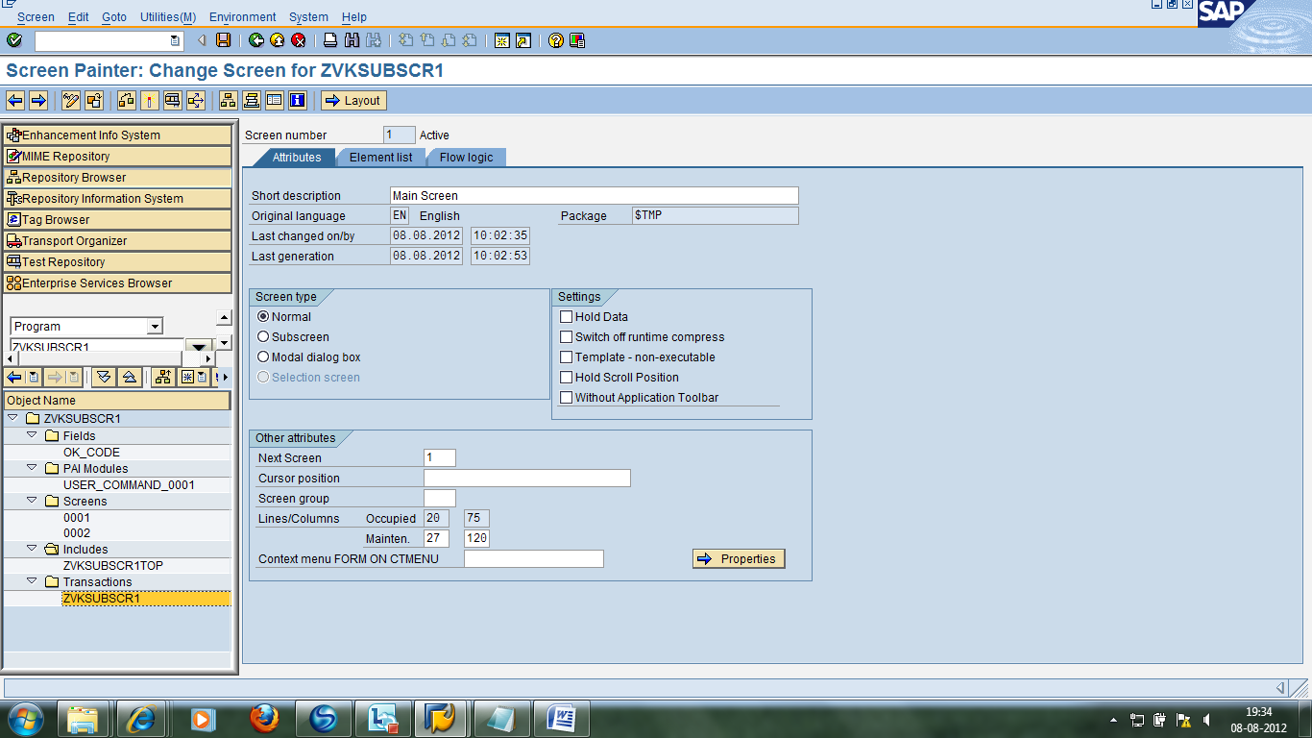

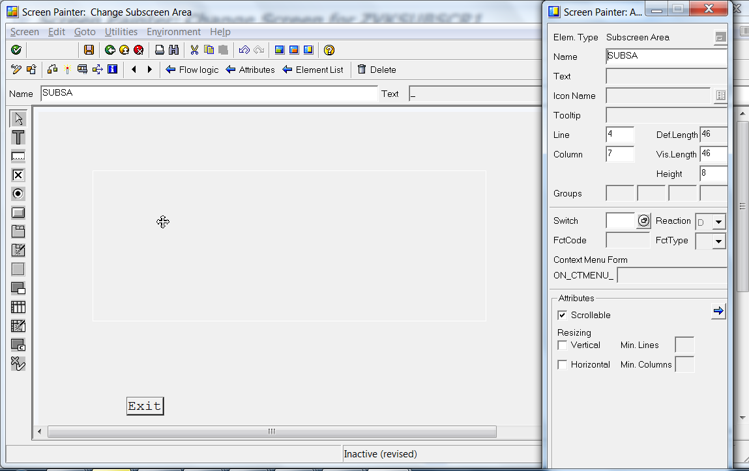

Note: You cannot put any objects in Subscreenarea.

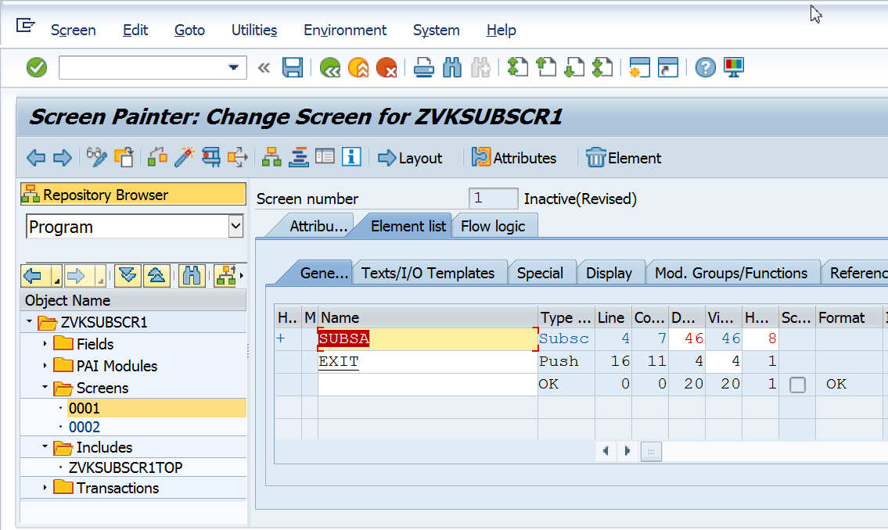

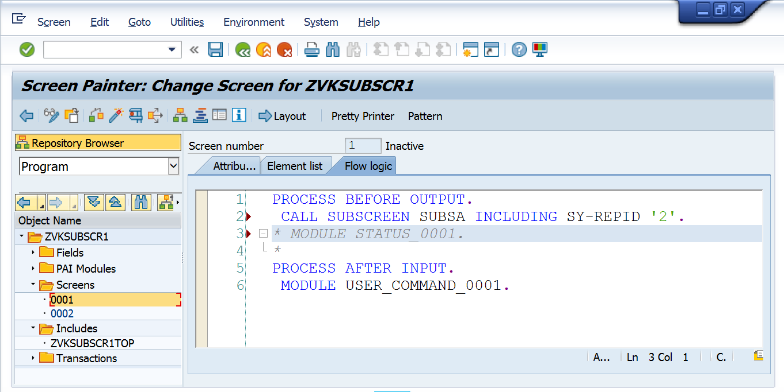

PROCESS BEFORE OUTPUT.  
 CALL SUBSCREEN SUBSA INCLUDING SY-REPID '2'.  
* MODULE STATUS_0001.  
*  
PROCESS AFTER INPUT.  
 MODULE USER_COMMAND_0001.

Note: No code is required in PAI.

The name of the subscreen is SUBSA.

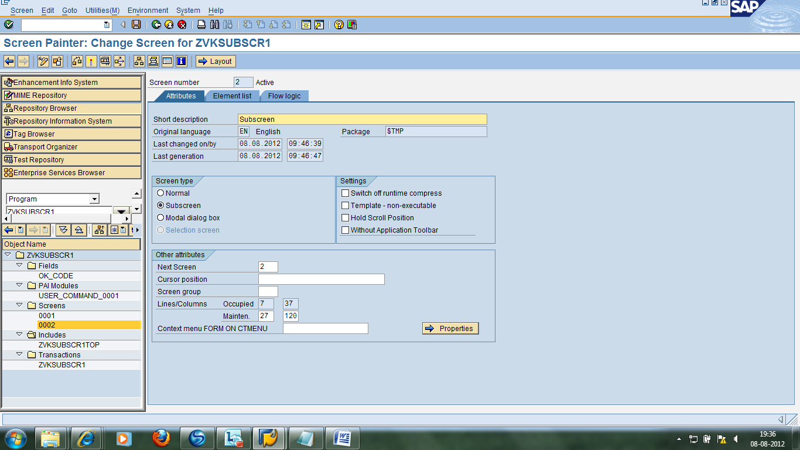

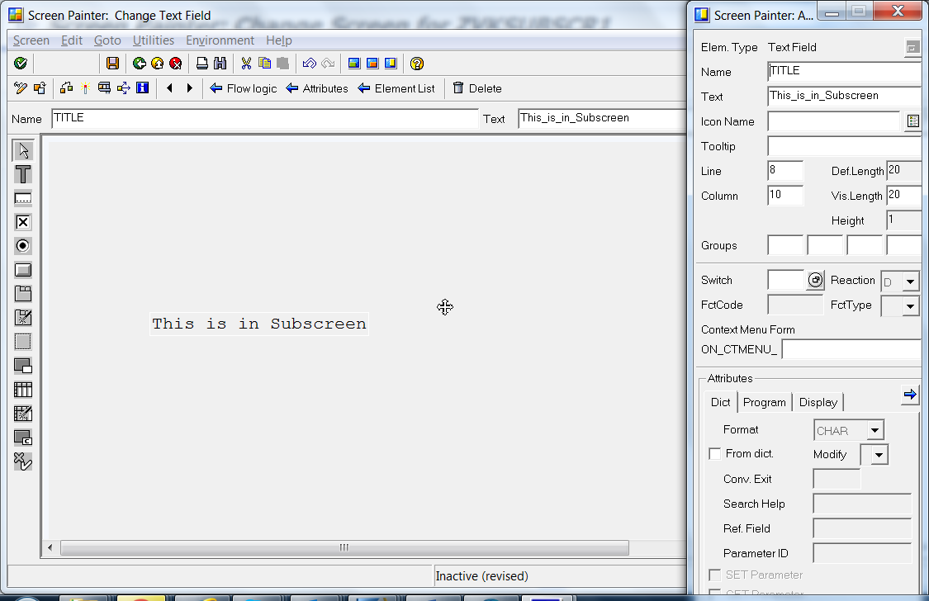  
*\*----------------------------------------------------------------------\**  
*\*\*\*INCLUDE ZNYN_MODULE_POOL_9_USER_COMI01.*  
*\*----------------------------------------------------------------------\**  
*\*&---------------------------------------------------------------------\**  
*\*&      Module  USER_COMMAND_0001  INPUT*  
*\*&---------------------------------------------------------------------\**  
*\*       text*  
*\*----------------------------------------------------------------------\**  
MODULE USER_COMMAND_0001 INPUT.  
CASE SY-UCOMM.  
WHEN 'EXIT'.  
      LEAVE PROGRAM.  
ENDCASE.  
ENDMODULE.

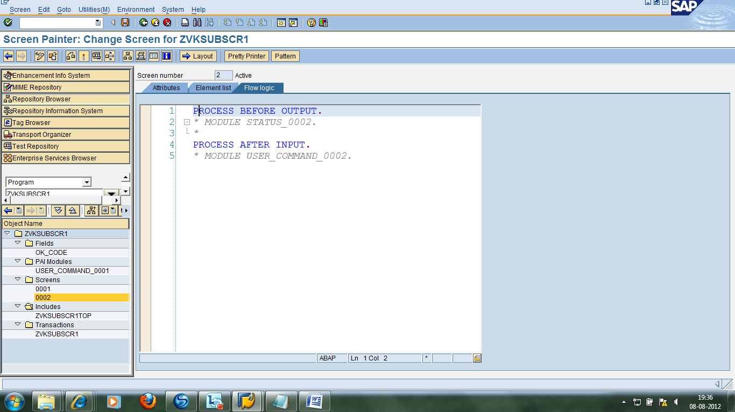

Create a transaction code and execute the program.